Game Engines Task 2

MCAST | Institute for the creative Arts

mcast institute for the creative arts

Luke Micallef | Andy attard

[Year]

***The target device (incl. screen resolution, input methods)***

The target device platform for our game will be mainly PC with the input methods being both the keyboard and mouse controls. The ideal screen resolution of the game will be 265x144 as it is the most commonly used resolution for 8-bit style games.

***Controls methods and game mechanics***

For our control methods, since we are going to do a game for a computer, the player will have the A/W and the space button as control inputs, and obviously a left mouse button in order to select things in the menu. As far as game mechanics, we have timing and dexterity

***Game screens***

* Main Menu Screen
* Controls Screen
* Pause Menu Screen
* Game Level Screen (Main scene)

***Gameplay flowchart***

The below is a flowchart which showcases the whole process and decision making of the game.

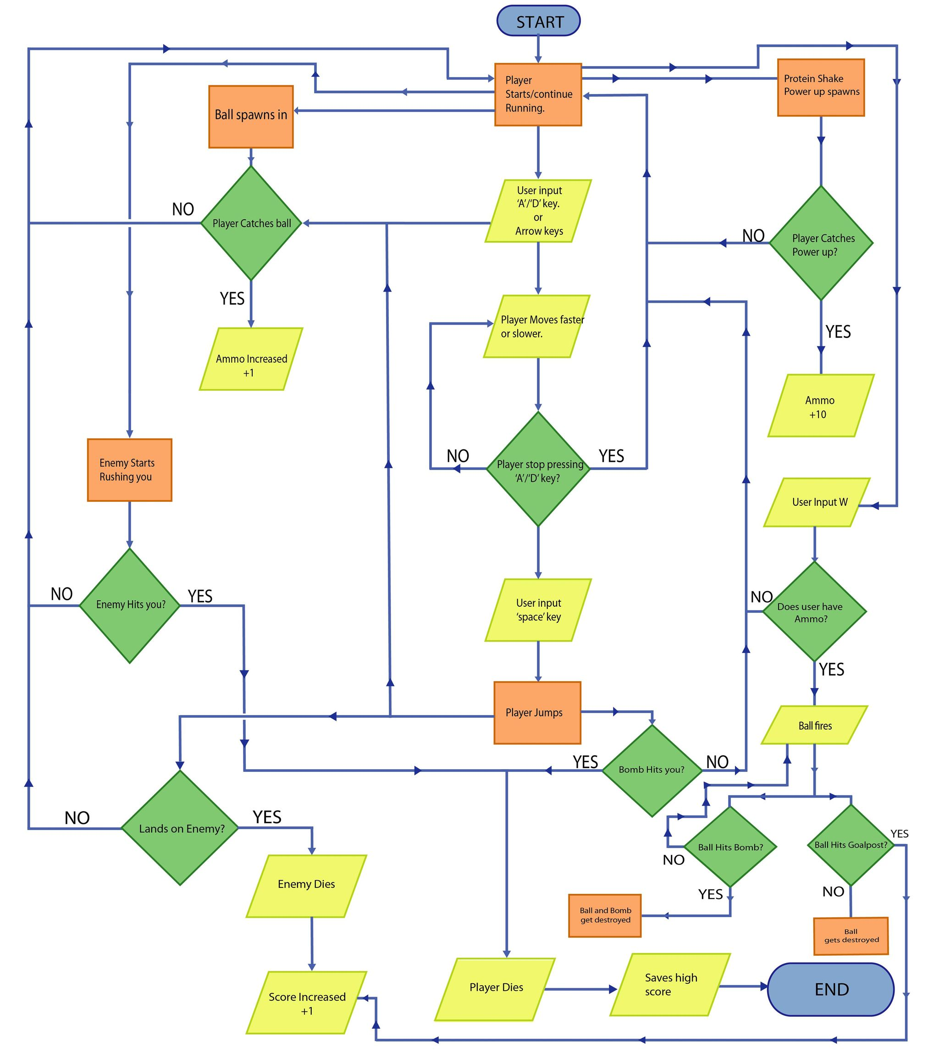

***Game objectives***

The objective for touchdown is score. Keep running and scoring for as long as you can before you die.

***Art assets (2D / 3D)***

************

Singular assets

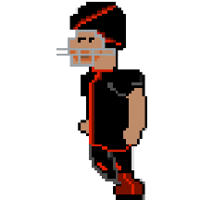

Enemy Sprites

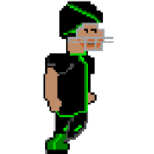

Player Sprites





Power up Sprites

 Warning

***User Interface outlines***

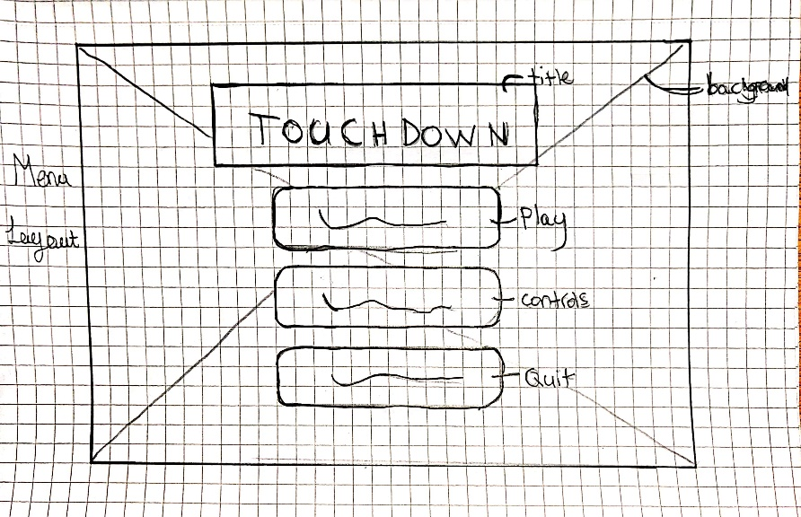

***Menu Screen***

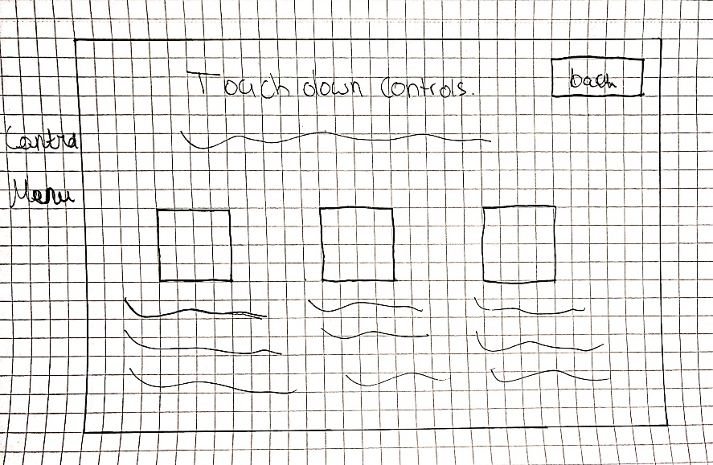

***Controls Screen***

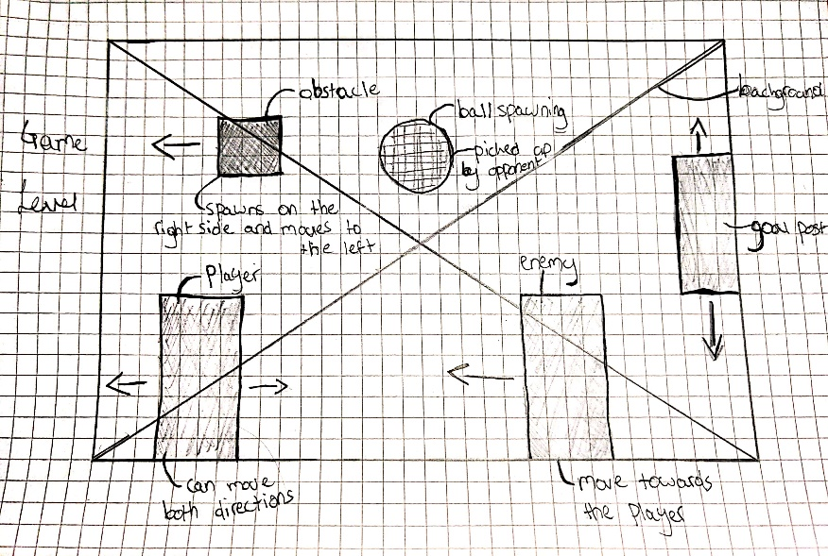

***Game Screen***